**GOWTHAM RAVUTHAN**

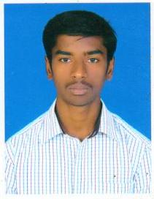

|  |  |
| --- | --- |
| **Title:** | **Software Associate** |
| **Location:** | Ahmedabad, Gujarat, India |
| **Languages:** | Tamil (native),English (fluent). |

# Experience Summary

**KEY SKILLS:**

* **Functional:** Excellent Communication and Interpretation skills, Analysis and Development.
* **Databases:**  Oracle, SQL Server
* **Web Technologies:** HTML
* **Programming Languages:** C, C++, Java Script
* **Automation Tools:** Selenium, Loadrunner
* To work in a challenging environment that provides opportunity to learn key technologies, be an effective team player and to be an asset for the organization by delivering to the best of my capabilities

# Experience

* Completed 3 months of VnV Automation Testing Training in Bangalore.



* In Automation COE Project – Selenium Tool
* Performance Testing - Loadrunner tool

# Higher Education

* Bharathiar University – B.Sc. Mathematics with Computer Application.

# Contact Details

|  |  |
| --- | --- |
| **Name** | Gowtham Ravuthan |
|  |  |
| **Mobile no.** | +91-8508239832 |
| **Email id** | rgowthambcs97@gmail.com |
| **Company Mail id** | gowtham.ravuthan@capgemini.com |
|  |  |
|  |  |
|  |  |

|  |  |
| --- | --- |
| **Permanent Address** | 73/60, Pillayar Kovil St,  Pallapalayam (PO),  Perundurai (TK),  Erode – 638 116,  Tamil Nadu. |

|  |  |
| --- | --- |
| **Alternate Mobile no.** | +91-8667866501 |